DEAD CODE ELIMINATION

AIM
To write and implement a C program to perform Dead Code Elimination on Three Address Code (TAC) by identifying and removing statements that do not affect the final program output.

PROGRAM
#include <stdio.h>
#include <string.h>
#include <ctype.h>
#define MAX 100
#define LEN 100
int main()
{
char code[MAX][LEN];
char lhs[MAX][LEN] = {0};
char rhs[MAX][LEN] = {0};
int live[MAX] = {0};
int n = 0, i, j;
char line[LEN];
printf("Enter Three Address Code statements.\n");
printf("Enter END to finish:\n");
while (n < MAX && fgets(line, sizeof(line), stdin))
{
line[strcspn(line, "\n")] = '\0';
if (strcmp(line, "END") == 0)
break;
if (strlen(line) == 0)
continue;
strcpy(code[n], line);
char *equal = strchr(line, '=');
if (equal != NULL)
{
*equal = '\0';
sscanf(line, "%99s", lhs[n]);
strcpy(rhs[n], equal + 1);
}
else
{
lhs[n][0] = '\0';
rhs[n][0] = '\0';
}
n++;
}
/*
Variables assigned to final program outputs
are considered live.
*/
for (i = n - 1; i >= 0; i--)
{
if (lhs[i][0] == '\0')
{
live[i] = 1;
continue;
}
int needed = 0;
for (j = i + 1; j < n; j++)
{
if (live[j] && strcmp(lhs[i], lhs[j]) == 0)
{
needed = 1;
break;
}
}
/*
Keep a statement if its result is used
by a live statement.
*/
if (needed)
{
live[i] = 1;
}
/*
Preserve externally visible destinations.
*/
if (strcmp(lhs[i], "x") == 0 ||
strcmp(lhs[i], "y") == 0)
{
live[i] = 1;
}
/*
Mark earlier definitions of variables
used by this live statement.
*/
if (live[i])
{
char *p = rhs[i];
while (*p)
{
if (isalpha((unsigned char)*p) || *p == '_')
{
char var[LEN];
int k = 0;
while (isalnum((unsigned char)*p) ||
*p == '_')
{
var[k++] = *p++;
}
var[k] = '\0';

for (j = i - 1; j >= 0; j--)
{
if (strcmp(lhs[j], var) == 0)
{
live[j] = 1;
break;
}
}
}
else
{
p++;
}
}
}
}
printf("\nOptimized Three Address Code:\n");
for (i = 0; i < n; i++)
{
if (live[i])
printf("%s\n", code[i]);
}
return 0;
}

PSEUDOCODE
- Start.
- Declare arrays to store Three Address Code statements, left-hand-side variables, right-hand-side expressions, and live statement flags.
- Read TAC statements from the user until END is entered.
- Separate each assignment statement into its left-hand-side variable and right-hand-side expression.
- Traverse the statements in reverse order.
- Identify statements whose results are required by other live statements.
- Preserve statements that assign values to externally visible variables (x and y).
- Mark earlier definitions of variables used by live statements.
- Display only the live statements as the optimized Three Address Code.
- Stop.

INPUT

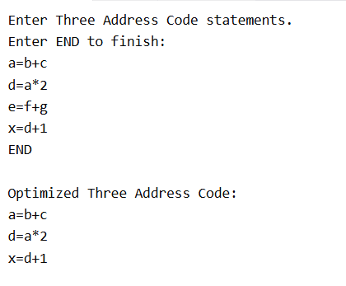

OUPUT

RESULT
Thus, the C program to perform Dead Code Elimination using Three Address Code was implemented and executed successfully. Unnecessary statements were removed, and the optimized code was displayed.

